1. Create an empty project

To create an IDE project:

1. Start NetBeans IDE.
2. In the IDE, choose File > New Project, as shown in the figure below.

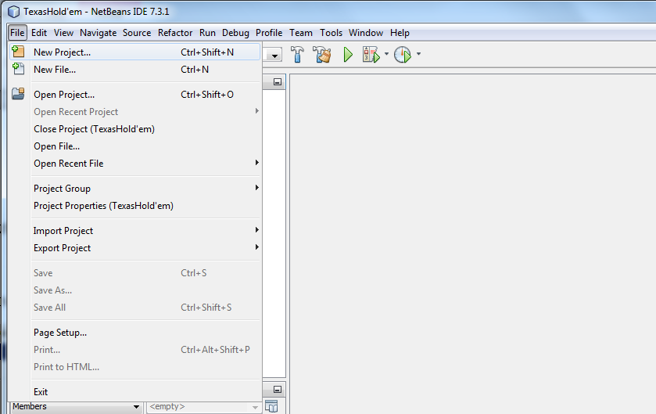

1. In the New Project wizard, expand the Java category and select Java Application as shown in the figure below. Then click Next.

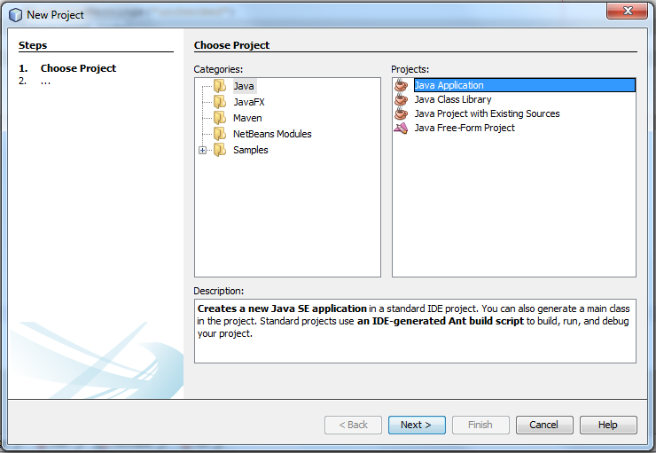

1. In the Name and Location page of the wizard, do the following:
   * In the Project Name field, type your project name: BMI
   * Click Browse, to select project location.
   * Leave the Use Dedicated Folder for Storing Libraries checkbox unselected.
2. Click Finish.

The project is created and will be opened in the IDE.

2. Create a GUI

Click File-> new File. Choose SwingGUIForm and JFrame Form, then Click next.

Enter a name for this class, such as BMIGui, then click Finish.

After click Finish, you will see a similar window like the following page. This is an empty frame. You can drag the component on the right window to build your own interface.

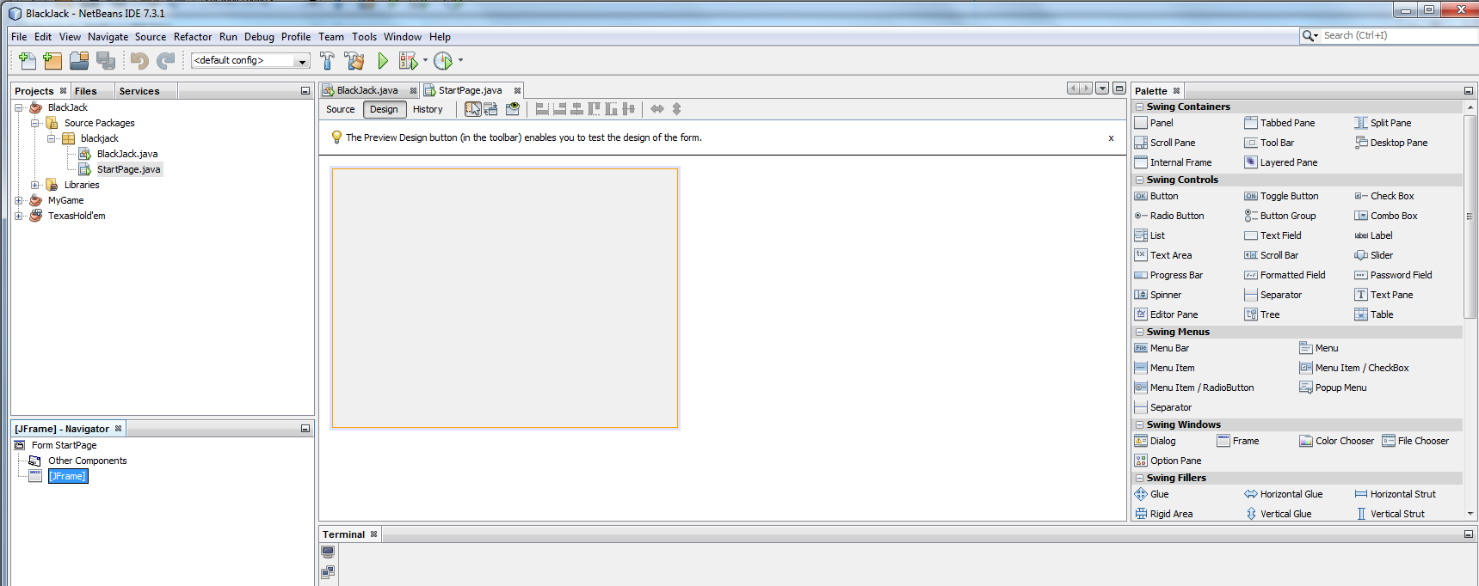

3. Build the interface: A BMI calculator

First: add a Layered Pane; drag it from the right window to your blank frame. Then enlarge the pane to make it cover your entire frame. Use the text fields and labels to build the following application.

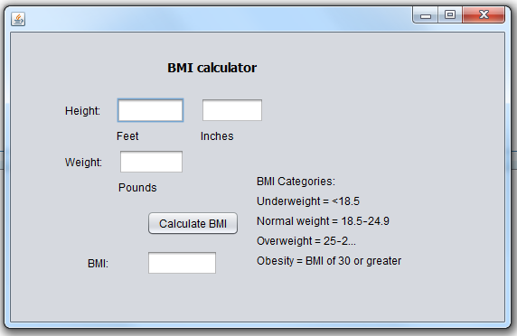

|  |  |
| --- | --- |
| [void setText(String)](https://docs.oracle.com/javase/8/docs/api/javax/swing/text/JTextComponent.html" \l "setText-java.lang.String-" \t "_blank) [String getText()](https://docs.oracle.com/javase/8/docs/api/javax/swing/text/JTextComponent.html" \l "getText--" \t "_blank) | Sets or obtains the text displayed by the text field. |

You need to convert value in the text field from String to integer when you do the calculation.

String feet = jTextField1.getText();

4. Create another java class Called BMICalculator. In this java class, you need to calculate the result of BMI.

How to Calculate BMI?

1 feet = 12 inches

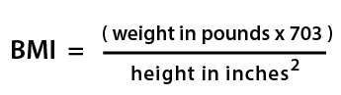

Example:

Jane weighs 150lbs and is 5 feet 4 inches tall.

Jane's height in inches is (5 \* 12) + 4 = 64"

1. multiply the weight by 703. 150 \* 703 = 105450

2. multiply the height by itself. 64 x 64 = 4096

3. Finally divide the first figure by the second. 105450 / 4096 = 25.7

Jane's BMI is 25.7 (keep one decimal place)

5. To run your project, you need to start from the main method. In you main method, you need to call you interface class BMIGui, like the following:

BMIGui bmiG = new BMIGui();

bmiG.setVisible(true); // this is how to make your interface show up.

Submission: submit the source code of all your .java files in a .zip format (find your project location and right click it, select send to compressed folder) and a screenshot of the results (use snipping tool for screenshot). In the screenshot, show four types of calculation.

Resources:

* Windows Snipping Tool for screenshots: <https://support.microsoft.com/en-us/help/13776/windows-10-use-snipping-tool-to-capture-screenshots>
* Java Scanner Utility: <https://www.w3schools.com/java/java_user_input.asp>
* How to use NetBeans: <https://netbeans.org/kb/docs/java/quickstart-gui.html>/docs/java/quickstart-gui.html